TESTIMONIALS – BILAT USA 4.0

**High-level EU Cluster Mission to the USA 15 to 19 May 2017, including a U.S. – EU Cluster Cooperation and Matchmaking Event at the TechConnect World Innovation Conference, Washington DC & Cluster visits to Boston, Cambridge and Philadelphia**

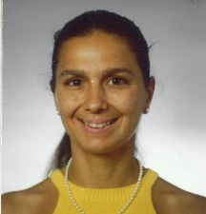Laura Cerni, CBM srl, Italy: “My cluster is active in the fields of Biomedicine, Biotechnology, e-Health and Ambient Assisted Living, so the cluster visits in Philadelphia, PA, which is a hub for life sciences, were of particular interest to me. It was very useful to understand the research and innovation landscape in the USA thanks to the presentations, meetings and visits, as it differs from the system we know from Europe. I am glad I can bring specific information home to my cluster’s member companies: indeed, I could already schedule a concrete appointment for one company that is visiting Boston next week with the group in charge of the Biomanufacturing Program at MIT, and with the Fraunhofer Center for Manufacturing Innovation, two of the organisations met in Boston during our cluster visit.”

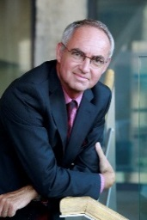Peter Simkens, DSP Valley, Belgium: “The matchmaking event in Washington, DC, was efficient for me, as I could discuss some opportunities of collaboration for our cluster and our members. As for the visits, I would be interested to learn more about the access opportunities and mechanisms for European companies to the Manufacturing America program that was presented to us. When visiting the Cambridge Innovation Center in Cambridge, MA, I realized that a number of our cluster’s member companies have already used the incubation and consulting services which were a great information mechanism for them and allowed them to enter the US market for sales whilst growing steadily in the EU. Their testimonials could be a great inspiration for others.”

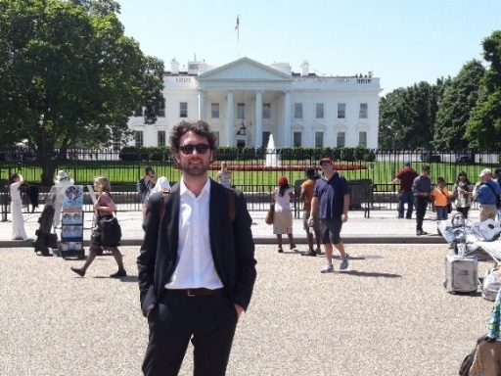Carlo Kraskovic, Mare FvG, Italy: “The mission has represented a great opportunity to getting aware about innovation and technology development framework in the USA, providing information on several actors with different competences and roles. Since our cluster is involved in the maritime technologies sector, during the matchmaking event we had the possibility to meet three American cluster focused on different maritime and marine topics. The before mentioned meetings helped us understand what they do and gave us the possibility to get more details on maritime topics that we could develop in the future.”

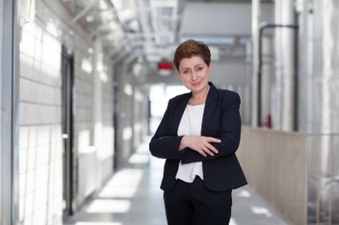Marzena Strok-Sadło, Lublin Medicine Cluster, Poland: “EU Cluster Mission to USA has been significantly important to further Lublin Medicine - Medical and Wellness Cluster development. During five days, thanks to good organization of the mission we had an opportunity to meet a number of key market and research players. We have gained the knowledge about the US system supporting economic and scientific development. We could also discuss the business model of our potential partners.

Matchmaking meetings in Washington allowed us to introduce our cluster directly to US and European organizations. The scope of potential cooperation has been defined. In two cases, we have already decided on signing the agreement on cooperation in the nearest future. Meetings in Philadelphia and Boston besides very professional presentations gave us an opportunity to meet personally people who are in charge of well-recognized US institutions. After being back to Poland and Lublin we have started to work on individual bases with partners we had met, structuring our initial ideas for cooperation.“

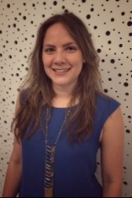Silvana Sanfeliu, Fondazione Torino Wireless, Italy: “The mission was helpful to understand how the innovation and acceleration services work in the USA. We got to meet different kind of entities and organisations that can be approached when searching for partners to support companies in their internationalisation processes, whether it is to open an office, analyse the market, develop joint projects or search for potential investors. The visits held in both Philadelphia (PA) and Boston (MA) gave us clusters a good perspective on the interest and goals of the US’ organisations we met and allowed us to start a dialogue that can lead to collaboration and cooperation with them. The matchmaking B2B meetings, in Washington DC, were effective, having more time to get to know the entities and have a deeper insight of how we can collaborate together. Torino Wireless manages 2 clusters that address ICT applied to different fields and sectors, with a particular emphasis in Smart Cities and Communities solutions, so, even if some of the meetings were centred in a specific sector (for example life sciences, biotech, etc.), I found interesting potentialities for ICT as an enabling solution.”

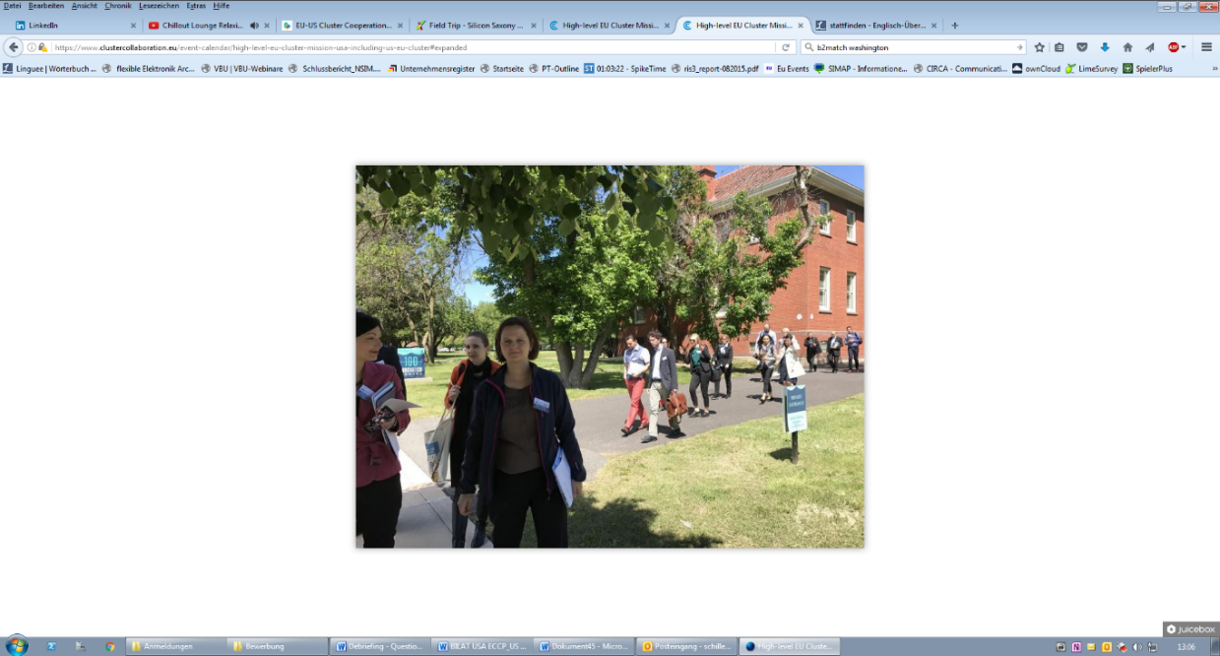Madlen Schiller, biosaxony e.V., Germany: “biosaxony is the association of life sciences industries in the Free State of Saxony (Germany). Our focus areas are biotechnology, medical devices and health. With over 110 members we are active in site marketing, technology transfer and business development. The cluster mission to the U.S. was a great opportunity for biosaxony to start collaboration with US clusters and business development agencies. The support services for soft landing and technology transfer of Ben Franklin Technology Partners in Philadelphia and the Cambridge Innovation Centre in Boston were particular interesting for us. The trip was well organized and we had the opportunity to talk to different stakeholders from universities, development agencies, cluster associations and start-up incubators.”

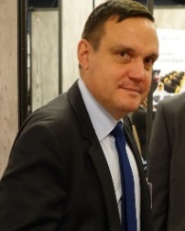Patrick Vuillermoz, PLASTIPOLIS, France: “The US cluster mission including the matchmaking event during the TechConnect Conference has been very fruitful by giving the opportunity to better understand the way American clusters are acting and developing their innovation eco-systems. This enabled to get leading edge practices in the combination of technology and business oriented communities for the benefit of start-ups and innovative companies. For our particular interest, we have been able to build up promising connections with cluster or economic development organizations in Pennsylvania such as Ben Franklin Technology Partners, or in Ohio such as Team Neo, as well as Mass TLC in Massachusetts. As complementary, the TechConnect annual conference in Washington brought us some key insights in technology trends related to our fields of interest such as material technologies, printed electronics, 3D printing or advanced manufacturing.”

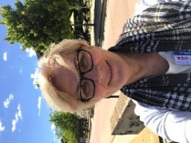Ewa Kochańska, Research and Innovation Center Pro-Akademia, Poland: ”It was a very interesting, useful visit for our cluster from the point of view of companies as well as research institutions. We could collect a lot of good examples of bridging industry and academia, rules of conducting research projects for companies, we could get familiar with and understand the American approach to interactions between science and industry, even if it is not called “cluster interactions”. The lesson learnt will be taken to Poland in order to implement the American model of thinking: Technology and demonstration + Training and education. We plan to find the complementary area of cooperation with the USA market, e.g. with regards to energy efficiency and energy saving technology, small scale RES technology, RES technology for e-mobility or waste-to energy technologies.”

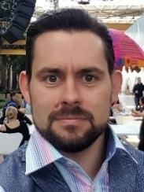  
Stefan Uhlig, Cool Silicon e.V.: “During the High-Level US-Cluster-Missions, I gathered lots of useful information and even more contacts for our cluster and the members, respectively. The learnings for our cluster regarding the remarkable entrepreneurial and seed-capital as well as VC ecosystem in Philadelphia (PE) and Boston/Cambridge (MA) will help our members, once they start their business in these regions. For R&D opportunities the Singh Center for Nanotechnology in Philadelphia was a very promising visit to connect with some of our research institutes. The meetings with MassTLC and MassCEC in Boston showed outstanding opportunities on the C2C-basis and furthermore some of our members in the wind turbine branch may conduct new businesses in the near future.”

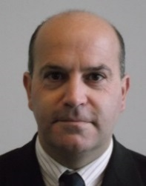Vincent Civita, ARIA Normandy, France: « The European mission was a very fruitful event for us. From one part, the program explorating the US East Coast provided us a good picture of the innovation and economical practices, which is very different compared to the well-known Silicon Valley. We met very open-mindset counterparts, with a real willingness to build collaborative projects with European entities. Also, we discovered different organizations involved in the local economy: Ben Franklin organisation helping the companies to set up in Pennsylvania, Navy Yard organizing economic and social life, Fraunhofer centers innovating in US, Manufacturing USA supporting US industry to be more competitive with a national and specialized projects with laboratories (like our Factory Of Future, Industry 4.0), Singh Center (University of Pennsylvania) with huge R&D portfolio,  … and an amazing “start-up push” process (Community innovation Collaboration) bearing the American entrepreneurship spirit.”

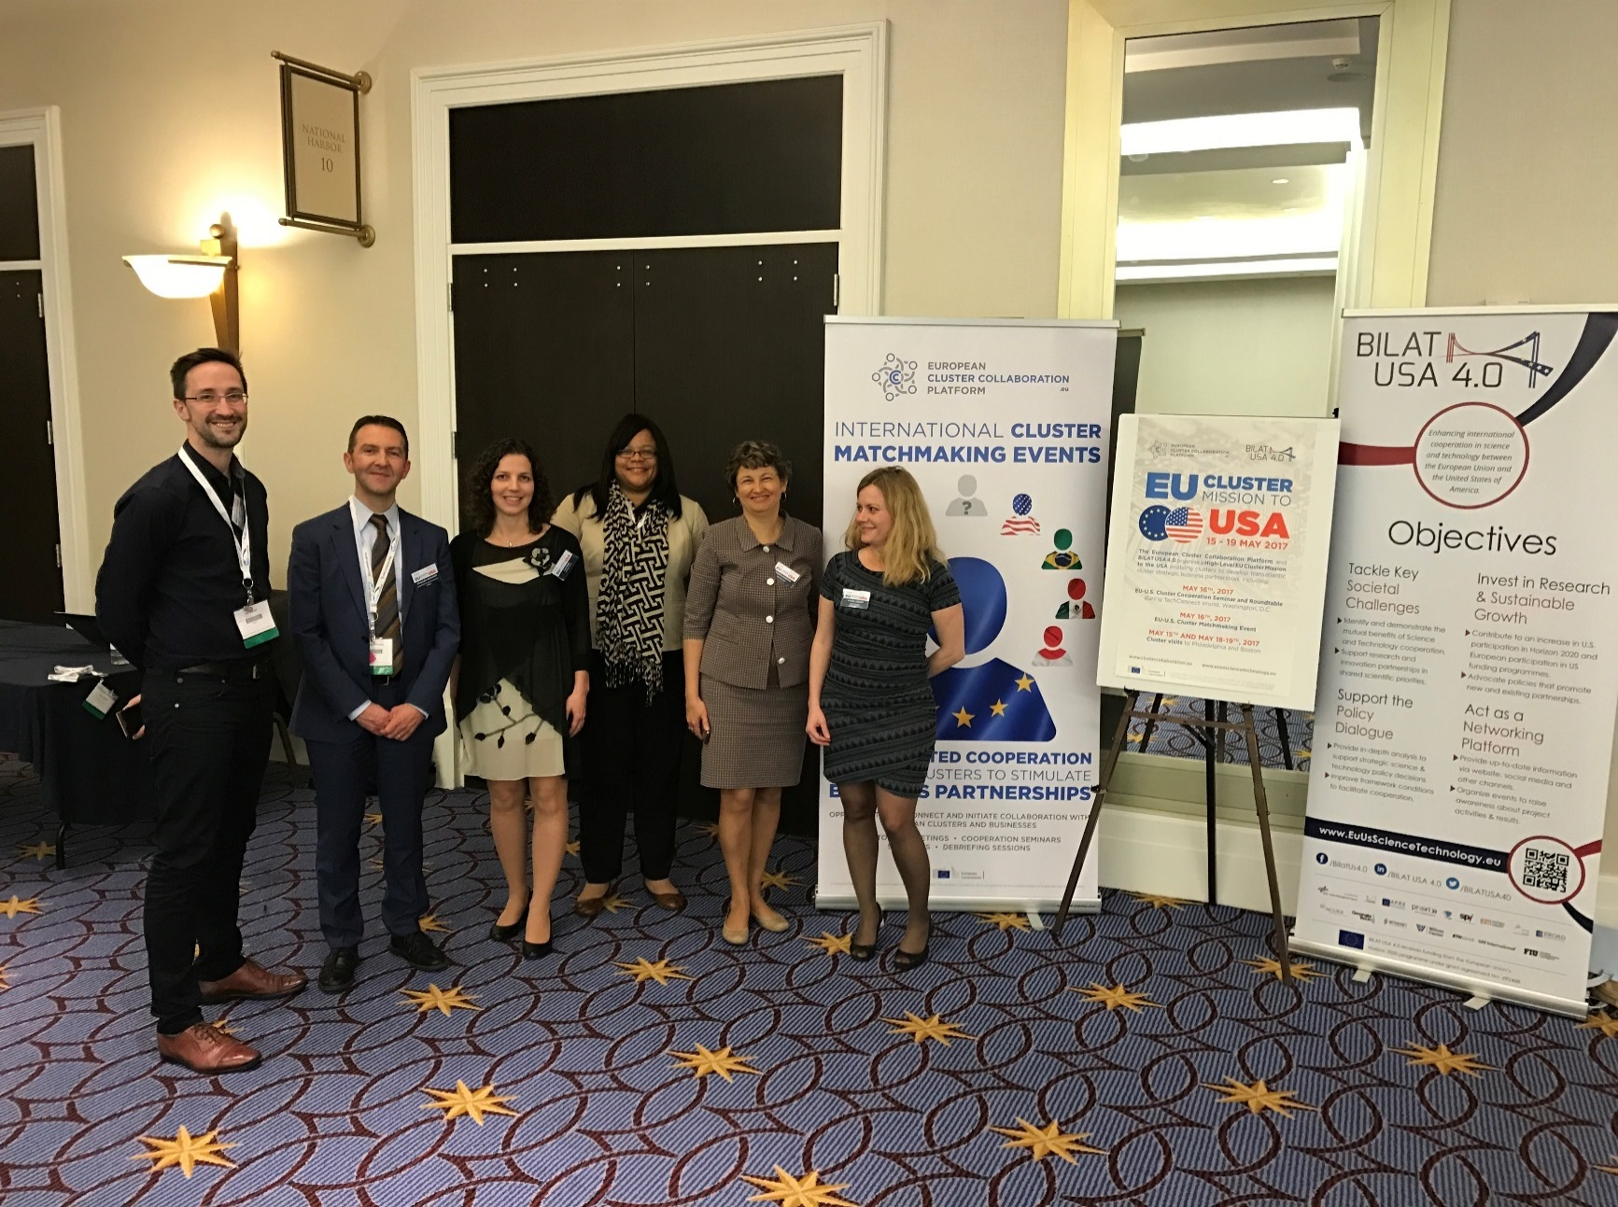Sam Goodall, Cambridge Cleantech, UK: “Thanks to everyone involved in the EU-US Bilateral Cluster Mission. I can’t speak highly enough of what a fantastic opportunity it was for Cambridge Cleantech as a technology cluster. I met over 70 potential collaborators and since returning have already followed up with 3 potential partner organisations with concrete next step actions, (two meetings scheduled in London and an outline for a US-EU Summit on Smart Grid Technology). Participating on the mission with over 20 other EU technology clusters was also extremely valuable and has exponentially grown our international network with other technology clusters in Europe within the space of just a few days. Likewise, this has already led to a concrete joint bidding activity for cluster collaboration. I was impressed with the work and activity of the European Cluster Collaboration Platform before this mission but now I’m positively evangelical; active participation in international cluster collaboration is hugely valuable for our members – particularly those who are looking for international research and collaboration opportunities - and the ECCP is a fantastic source of information and resources for us to support them in doing this. Thanks again to everyone who was involved and organised such a fantastic mission – I can’t stop telling people about it and it was a real privilege to be involved.”

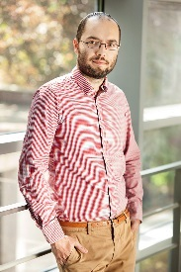Marcin Paradowski, ECDF mKlaster, Poland: “The High-level EU Cluster Mission to the US was a great opportunity to understand how the innovation ecosystem works there. We had an opportunity to exchange experiences with different kind of entities, from business support institutions, through R&D institutions, up to the VC ecosystem. It was a fruitful set of C2C matchmaking meetings and direct visits at local institutions. We came back with promising contacts and knowledge about the wide range of services offered by the US organisations what let us develop further cooperation. As an ICT cluster we are very satisfied that we confirmed during this meetings that there is a need for better collaboration between the US business environment and the European ICT sector as well as we get concrete tools to make this collaboration possible.”